

Masters in Computer Science with Cyber Security
Department of Computer Science

Implementing the Zero Trust Security Architecture in Enterprise Networks:
A case study of financial institutions in Kenya.
Submitted By:
Lucy Wanjiku Mbugua

Supervisor: Dr Piyush Dhawankar

A thesis submitted to University of York in partial fulfilment to the
requirements of the Master of Science in Computer Science with Cyber Security

March 2022

Executive Summary
The digital transformation has led to the evolution of information technology introducing concepts such as cloud computing, big data, Internet of Things, mobility etc. While this has improved operational efficiency, workforce, and customer experience, it has also created complexity in securing enterprise infrastructure. The modern enterprise network has no clear security perimeter anymore and the traditional perimeter-based architecture is not sufficient to enforce security in the modern enterprise. Threats are growing exponentially both in number and in sophistication. Organizations must assume they have already been compromised and act like it.
The Zero Trust security architecture by Forrester Research aims to address the challenges with traditional perimeter-based approaches to security by introducing the concept of always assuming breach, never trusting and always verify. It introduces an end-to-end approach to security encompassing identity, credentials, access control, operations, endpoints, hosting environment and the interconnecting infrastructure.
Zero Trust is being adopted rapidly and this research aims to create a predictive model to be used in an application that can predict where an organization is in their journey to a Zero Trust network and provide recommendations on the security measures and solutions to adopt to address security weaknesses in their networks.
Data to train the predictive model was collected from different financial institutions in Kenya that include banks, insurance companies and Savings and Credit Co-operative societies (SACCOs). The target population was the network and security administrators in these institutions.

Table of Contents
Executive Summary ii
List of Tables v
List of Figures v
Acknowledgements vi
Declaration vii
Chapter 1 1
Introduction 1
1.1 Background 1
1.2 Motivation 3
1.3 Research Objective 3
1.4 Research Aim 4
1.1. Research Questions 4
1.2. Research Hypothesis 4
1.3. Structure 4
Chapter 2 5
Literature Review 5
2.1 Background Review 5
2.2 Zero Trust Security Model 6
2.3 Zero Trust Network Security 9
2.4 Zero Trust in SDN 10
2.5 Zero Trust Identity Security 13
2.6 Zero Trust Endpoint Security 14
2.7 Industry Players Adoption of the Zero Trust Security Architecture 16
2.8 Parameters to Measure Zero Trust 17
2.9 Conclusion 18
Chapter 3 20
Research Methodology 20
3.1 Introduction 20
3.2 Research Design 20
3.3 Target Population 21
3.4 Sampling 21
3.5 Data Collection 23
3.6 Ethical Considerations 23
Chapter 4 25
System Analysis and Design 25
4.1 Introduction 25
4.2 System Development Methodology 25
4.3 System Architecture and Design 27
4.3.1 Requirement’s analysis 27
4.3.2 System architecture 27
4.3.3 System design 27
4.4 Programming Tools 29
Chapter 5 30
Data Analysis, System Implementation and Testing 30
5.1 Introduction 30
5.2 Survey Responses 30
5.2.1 Summary statistics 33
5.2.2 Pearson’s Correlation 33
5.2.3 Respondent’s use of encryption among the different institutions 35
5.2.4 SDN adoption among financial institutions 36
5.2.5 Network segmentation adoption among financial institutions 39
5.2.6 Use of security policy engine for access control among financial institutions 39
5.2.7 Use of MDM updates among financial institutions 40
5.2.8 Use of Data Loss Prevention for Endpoints 41
5.3 Inferential Statistics 42
5.3.1 Statistical Test Validation 42
5.3.2 Chi-Square Test (Person’s) for independence 43
5.3.3 Hypothesis testing using Ordinal Logistic Regression (OLR) 43
5.4 System Implementation and Testing 45
Chapter 6 46
Summary, Conclusion and Recommendations 46
6.1 Research Summary 46
6.2 Conclusion 46
6.3 Recommendations on future work 47
Appendices 48
Appendix A 48
Appendix B 49
Appendix C 50
Survey Questions 50
Abbreviations 52
References 53

List of Tables

Table 1:Stratum sample size calculation 23
Table 2: Variable breakdown 33
Table 3: Measures of central tendency 35
Table 4: Correlation between continuous variables 36
Table 5: Software defined access/branch adoption 38
Table 6: SDWAN adoption 39
Table 7: Software defined data center adoption 39

List of Figures
Figure 1:Logical Components of a Zero Trust Architecture [3] 7
Figure 2: Zero Trust Model PEP distribution [3] 15
Figure 3: Sample size formula [49] 22
Figure 4: Waterfall model [42] 25
Figure 5:System architecture 27
Figure 6:Use case diagram 28
Figure 7:Sequence diagram for the user interactions 29
Figure 8:Survey response distribution among financial institutions 31
Figure 9:Banks use of encryption level 35
Figure 10:SACCOs use of encryption level 35
Figure 11:Insurance companies use of encryption level 36
Figure 12:Zero trust adoption with software defined access/branch 38
Figure 13:Zero Trust adoption with software defined wide area network 38
Figure 14:Zero Trust adoption with software defined data center 38
Figure 15:Percentage of institutions implementing network segmentation 39
Figure 16:Percentage of institutions using a security engine use for access control 40
Figure 17:Use of Mobile Device Management in Banks 40
Figure 18:Use of Mobile Device Management in SACCOs 41
Figure 19:Use of Mobile Device Management in Insurance Companies 41
Figure 20:Institutions using Data Loss Prevention 42
Figure 21:Chi-Square test results 43
Figure 22:Ordinal Logistic Regression test results 44
Figure 23: Zero Trust vendors (Gartner 2019)[32] 49
Figure 24:Forrester Wave Zero Trust eXtended Ecosystem Platform Providers, Q3 2020 [33] 50

Acknowledgements
My sincere gratitude to Dr. Piyush Dhawankar who devoted his time and knowledge in this topic and provided valuable advice and direction.

Declaration
I declare that this work has not been previously submitted and approved for the award of a degree by the University of York or any other University. This thesis contains no material previously published or written by another person except where due reference is made in the thesis itself.

Chapter 1

Introduction

Background
The evolution of business models, shifting workforce dynamics, and technical innovation increases complexity in securing assets within the network [1]. A survey by Forrester on the concerns of global decision makers identified that complexity of IT environments remains the number one security challenge [2]. Security teams responsibilities are expanding, and priorities are shifting to comply with new laws, counter the evolving threat landscape as well as manage the day-to-day tactical activities. Policies such as Bring Your Own Device (BYOD) and remote working introduce further attack vectors while at the same time clients, partners and suppliers all need secure access to corporate resources. Internet of Things (IOT) adoption, use of Software as a Service (SaaS) and the shift to cloud has increased the attack surface, providing new pathways to exploit the vulnerabilities in the network [3]. This is attested by the many security breaches happening globally.
Additionally, new laws, and regulations on personal data use and security such as General Data Protection Regulation (GDPR) and Kenya’s Data Protection Act introduces additional scrutiny from stakeholders, regulators, executives, and potential clients in different organizations. These laws require organizations to shed light on information regarding their security processes, protocols, and personal data usage [4]. This requires companies to invest in privacy and GDPR compliance [5]. At the same time in the face of budget cuts, the IT teams are expected to work with lean budgets with expectations for better cost efficiency, more unbiased insight, and timely response to incidents [3]. Forrester Research [6], attests that Chief Information Officers (CIOs) are under intense pressure to cut technology budgets irrespective on the fact that technology is crucial to business operation and survival.
The COVID-19 pandemic has seen more users connecting from different places than ever before, which has driven many organizations to a hybrid workplace model. The hybrid model introduces a new challenge for IT teams to secure the access of remote workers to corporate resources while ensuring a consistent user experience [1]. In addition, today’s data centers are changing. There is an explosion of data brought from big data analytics. Virtualization and Software Defined Networking (SDN) are increasingly being adopted in the data center [3]. The workloads are now dynamic and moving across multiple on-premises or physical data centers and multi-cloud environments [7]. Data and applications are no longer confined to the data centers within the corporate network and behind the perimeter firewall. Applications are now everywhere, and critical workloads are being run from the cloud. As the workloads expand and contract, the underlying security policies must adapt [7]. DevOps teams are moving increasingly to Continuous Integration and Continuous Delivery (CICD) and rolling out new applications and services quickly [3]. Micro services, containers, and Application Programming Interfaces (APIs) are transforming how applications are being designed today [2]. These new trends are now making today’s data center incredibly complex which requires organizations to re-think their approach to security [1].
In the industry today, there are many security vendors offering security solutions deployed at different parts of the network. Organizations invest in these technologies and not only is the acquisition cost of all these solutions extremely high, but the cost of resources to manage and maintain them is also high [1]. With the many point security products available in the market today, some organizations invest in the latest security products to fix a known gap, instead of reviewing the security architecture holistically [2]. This results to a myriad of security products that security teams cannot manage or integrate. Some of these solutions may be solving the same problem, difficult to integrate and may not meet the required industry standards. In addition, many security technologies may require a complete review and overhaul of the existing security architecture to adapt to the latest risks which is not a sustainable model for IT teams that are constantly faced with budget cuts [2]. Subsequently, innovative malicious actors leverage speed, agility, adaptability, and destruction to achieve their objectives and therefore requires new defenses [3].

Motivation
The Zero Trust security framework according to Forrester research is identified as a new shift to address security through the concept of never trust, always verify and assuming breach [7]. It recommends transforming security to a more dynamic, identity-centric, and policy-based approach rather than perimeter-based approaches [3]. Zero Trust Network Architecture (ZTNA) has become a focus area for security vendors globally and institutions due to its effectiveness in eliminating critical weaknesses in traditional networks that could allow malicious actors to traverse the network after infiltrating the firewall [8]. Since there is no security solution that is one hundred percent effective and there is a possibility of an organization getting compromised, the Zero Trust security architecture ensures that the compromise is restricted to specific segments of the network and has a great potential to mitigate against data loss in the event of a security breach [9].

Research Objective
The research objective is to identify the Zero Trust security solutions and measures adopted in the network, identities, and endpoints in financial institutions in Kenya to determine the Zero Trust adoption level and accelerate the Zero Trust strategy adoption.

Research Aim
This research aims to provide a predictive model that identifies where financial institutions are in the journey to a comprehensive Zero Trust security architecture and recommends additional security measures and techniques to address the network, identities, and endpoints security to enable Zero Trust.

Research Questions
- What are the security measures and techniques that are employed to address security challenges in financial institutions in Kenya?
- What is the level of Zero Trust adoption among financial institutions in Kenya?

Research Hypothesis
The research hypothesis for this project states that implementing comprehensive information security measures and techniques enables a high level of Zero Trust adoption in an enterprise network.

Structure
This thesis is structured as follows. Chapter 2 consists of the review of existing literature on Zero Trust to provide a foundation to understand the research and an analysis of the arguments presented. Chapter 3 provides insights on the research design and methodology to be used in the collection of data from financial institutions in Kenya to train the predictive model. Chapter 4 presents the system design of the application leveraging the predictive model to determine the Zero Trust adoption of financial institutions. Chapter 5 presents the findings from the data collection and analysis and chapter 6 provides a summary, conclusion, and recommendations from the research.

Chapter 2

Literature Review

Background Review
Traditionally, perimeter security has been the key security enforcement point where user authentication happens, and the user is permitted to access the internal network [3]. Subsequently, the user is then considered trusted through implicit trust, and everything inside the corporate network is considered trusted [3]. All data and applications are put in a data center and a trust boundary created around it that is referred to as the perimeter. Everything behind the perimeter is accessed via some authorization mechanism usually over a transport like Virtual Private Networks (VPN), over Wi-Fi, Local Area Network (LAN) cable or even directly attaching to a switch or router that connects to the applications behind the trust boundary. However, an attacker can easily gain access to any one of these applications for instance using credentials of an authorized user or via a backdoor into the application. The attacker in such a case can access just about everything as it is behind the perimeter of trust that has been established.
In 2008, in a cyber-attack dubbed operation Aurora, several organizations in China were hacked by state actors [10]. The hackers targeted several organizations among them Google, where they leveraged highly targeted spear phishing to infect the organizations with zero-day malware, which then exfiltrated confidential information and intellectual property out of each organization [10]. They were able to penetrate their perimeter and gain access to a range of applications that enabled them to move laterally across the network into other data centers resulting into the theft of sensitive data [11]. This forced Google to evolve its access control system through an initiative known as Beyond Corp that applied Zero Trust in its network architecture. In the industry today, consumers are beginning to hear more about Zero Trust as a new way to protect organizations across a wide spectrum of threats. Despite many companies touting Zero Trust as a set of products, the fact of the matter is that it is a paradigm, a core shift in how network security should be approached.

Zero Trust Security Model
Zero Trust is a term coined by Forrester in 2009 that centers on the belief that trust introduces a vulnerability and therefore security must be designed with the strategy [12]. Forrester’s Zero Trust eXtended (ZTX) involves breaking down traditional perimeters into a series of micro-perimeters or network segments to apply granular security controls around them [12]. Chase [12] also acknowledges that this is more than just network segmentation but comprises of a more holistic approach to secure the network, data, and applications. Aniket [8] identifies Zero Trust as a holistic approach to security comprising of principles and technologies to be incorporated in the network.
According to Forrester [7], the Zero Trust Architecture (ZTA) brings a paradigm shift to security by introducing the concept of never trust and always verify. This entails a verification of every user and device that attempts to access corporate resources inside or outside the network. This is critical to the operations of any organization as both internal and external threats can compromise entire networks resulting to data loss and reputation damage. It is necessary to protect network elements from the outside world and equally as important to protect them from each other [13]. Evan and Doug’s [11] study on Zero Trust requires that all hosts are considered internet-facing and the networks they reside in hostile and compromised. In this approach, secure communication can be built by ensuring that the organization adequately segments the network and network resources to prevent unauthorized access.
John [14], coined the term Zero trust and identified the following components in the figure below as the key logical components of a Zero Trust network architecture.
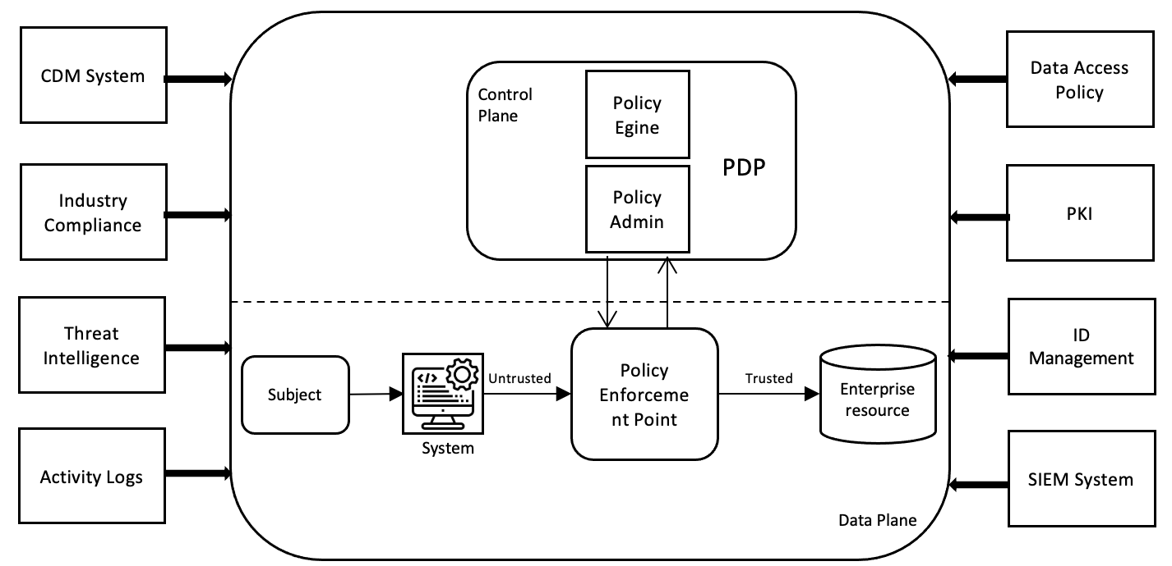
Figure 1:Logical Components of a Zero Trust Architecture [3]
National Institute of Standards and Technology (NIST) identifies a subject as either a user, device or application that operates on a computer system and has access to enterprise resources [15]. In the control plane, the Policy Decision Point (PDP) stores and makes policy determinations. The policy engine uses the policies set to allow or deny access to corporate resources. The policy administrator executes the decision arrived at by the policy engine [16]. In the data plane, the Policy Enforcement Point (PEP) enables, monitors, and terminates the connection between a user and the resources. It also sends and receives policy related updates from the policy administrator [16]. The PDP and PEP communicate on a logically separated network that is not directly accessible by enterprise assets and resources [3]. The data plane is used for application data traffic [16].
The Continuous Diagnostics and Mitigation (CDM) system collects information about the company assets and provides this information to the policy engine for the assets making requests to access resources while the industry compliance system ensures the organization is compliant with any industry rules and regulations [16].
The threat intelligence feeds provide threat information such as software flaws and vulnerabilities, malware etc. that enables the policy engine to make decisions [16]. In addition, the network and system activity logs provide real time information on network events that depict the security posture of the organization [16].
The data access policies consist of the rules and policies set to access corporate resources and can be encoded using the policy engine while the enterprise Public Key Infrastructure (PKI) generates, and logs certificates issued by the organization to resources, applications, and services [16].
The identity (ID) management system creates, stores, and manages the user accounts in the organization [16]. It leverages other systems such as active directory to get information related to the users.
The security information and event management (SIEM) system gather security related information, correlate security data from different sources and analyzes it to create policies [16].
A study by Songpon and Tetsutaro [9] on migrating to a Zero Trust architecture, highlights that a subject must gain trust from the system through the process of authentication and authorization. Authentication is the process of determining if a user or device is who or what they claim to be while authorization entails determining the privileges or access levels of a user or device and granting the permissions based on this [8]. The assumption is that any person or device trying to access the system or resource is a threat until authorized, inspected, and secured. This can be enforced on every request and transaction to enable granular control and privilege management. Aniket [8] reinforces this by identifying that Zero Trust relies on several preventative techniques such as multifactor authentication to confirm the user’s identity and enforce network access control. This implies that basic authentication is not sufficient. However, IT teams must seek a balance between security and usability to prevent user friction.

Zero Trust Network Security
Firewalls, Intrusion Detection Systems (IDS) and Intrusion Prevention Systems (IPS) have been relied upon as a key security control to separate the internal and the external network that is considered unsafe [12]. Chase [12] argues that there is a false assumption implied today that hosts that share a trusted zone are equally trusted. The risk with assuming that the hosts are trusted is that malicious subjects can gain access and traverse the internal network further compromising the network [9]. While the firewalls, IDS and IPS are still important in the modern age, additional security measures and techniques are required to ensure better network security.
First and foremost, it is critical to have tools that allow the secure identification, provisioning and monitoring of network devices [17]. Dwight and Suku [17] recommend identification using certificate-based authentication schemes like X.509 using a Trusted Platform Module (TPM). They also claim that while Zero Trust networks leverage existing protocols and libraries, they can be strengthened by new standardized protocols that allow for interoperability for example transport access control and first packet authentication protocols [17]. More research is required on this as adoption of new standards that are not supported on existing infrastructure may highly impact the adoption of the Zero Trust architecture due to the high cost of replacing network infrastructure.
Additionally, vulnerabilities that exist in network devices such as routers, switches, firewalls, servers etc. can pose a huge security risk. Network devices should be in the most secure state ever. This requires continuous assessment of vulnerabilities and enforcement of timely patching of the operating system and firmware as well as disabling legacy protocols in use [17]. In addition, network refresh to replace critical infrastructure as well as keep abreast with ongoing innovation is necessary as the older the device the greater the possibility of compromise.
Network access control relates to user identification and authentication, user device validation and policy enforcement that dictates the network resources a user is permitted to access [3]. The policy enforcement should incorporate the least privilege principle. Privileged accounts credentials are a key target for hackers and therefore administrative access to devices and applications must be reviewed constantly to ensure that privilege access is not misused [18]. Backup of admin action logs will also ensure that in the event of a compromise and the system logs are deleted, there exists a copy for analysis. In addition, incorporating encryption of network communication using certificates as well as machine learning based threat protection and automated remediation can thwart any attempts at compromising the network quickly and efficiently.

Zero Trust in SDN
SDN is an architectural design that separates the control plane from the forwarding plane in network devices, allowing the network to be centrally managed via a controller [19]. Evan and Dough [20] indicate that Zero Trust networks require automation systems to be built and operated. The traditional network has evolved to the software defined network, which introduces automation of network management that supports Zero Trust [20]. SDN separates the introduces the concept of control plane and data plane that are critical for automation. This provides support for network monitoring and control functions that have never been available to network operators. Programming the network becomes easier as many operations that need to be executed can be automated minimizing the risk of missing some steps. In addition, networks experience significant change over time. Links fail, network traffic increases, and maintenance must take place. When these changes happen, the network policy that is currently used by the network needs to be changed. This opens the possibility that changing the network policy could result in forwarding loops, security breaches, or transient outages [19]. To avoid these conditions, changes must be applied to the network in a consistent manner leveraging automation.
To meet the requirements of the digital age, the traditional network has some shortcomings in scalability and complexity in management [20]. SDN seeks to address these shortcomings. Maturity of the SDN market has resulted to different product offerings from the major networking vendors on SDN for the branch or access, data center and wide area network [21]. In any new technology security becomes an area of concern due to the emergence of new threats and implications of its use. [21]. Security in SDN is a core component of the network and not added as just an overlay service on top of an existing network [22]. Natalie [22] argues that the security afforded by an SDN architecture is only as good as the security of the SDN itself. As a result, any compromise of an element of the SDN architecture affects the integrity of the entire network.
Organizations in financial services consider security as a key factor in adoption of any technology as they hold, manage, and protect customers' money and financial information. They are regulated by several data privacy, security, and compliance regulations such as General Data Protection Regulation (GDPR), Payment Card Industry Data Security Standard (PCI DSS), Payment Services Directive (PSD2), Data Protection Act etc.
The programmable nature of SDN allows the customization of security services which are stronger than traditional security services [23]. This provides a flexible, dynamic network architecture that can be changed quicky and efficiently. With flexibility and a dynamic architecture, network engineers can efficiently configure, troubleshoot, and secure networks more efficiently. The programmable nature of SDN gives the engineer multiple controls on the network traffic and devices which is an advantage. However, a key security risk with this is the compromise of the SDN controller which can manipulate the entire network. Robin [23], argues that SDN’s key benefit is enabling network operators to manage the entire network through a controller which provides a platform for centralized configuration, policy and security management and its benefits outweigh the risks. To ensure the security and privacy within the network, certain changes in the architecture needs to be made and the Zero Trust uniquely addresses the security challenges in the digital age [23].
SDN defines a clear separation between the control plane and the data plane like the Zero Trust architecture. In SDN, the control plane defines how packets are to be routed in the network and the data plane is responsible for packet forwarding [19]. Networking benefits from the decoupling of planes as complex network functions can be implemented in software and scalability can be easily achieved [24]. The controller and the network applications interact with each other via the northbound interface that should allow only trusted network applications to program and request services from the network [25]. The Zero Trust security model can plug into the SDN architecture and play a critical role in enabling security and network segmentation and micro segmentation.
  - Zero Trust Identity Security
Microsoft defines identity as the ability to clearly and identify a person, device, location, or application to verify who or what they are in a network [26]. In identity-based networking, authentication, access control and user policy enforcement secure the network connectivity and resources [27]. Network access security requires that the network is protected from internal and external unauthorized users and devices at all network access points and the authentication and authorization of all users and devices attempting to access the network and applications.
There are three major methods of authentication. They are something you know, something you have, and something you are. Sirapat [28] defines Multi-Factor Authentication (MFA) as the use of two or more different factors to achieve authentication. These factors include use of biometrics, One Time Password (OTP), smartcards, mobile devices etc. which can remove the use of static passwords in authentication [28]. Aniket [8] argues that while multifactor authentication is critical for the security of the organization, the element of least privilege in the Zero Trust security model reinforces security by giving users and devices the lowest level of access possible. This prevents lateral movement in the event of a breach hence limiting the attack surface.
The Zero Trust security strategy is centered around the users, devices, and applications [9]. It provides control on the user privileges and permissions, devices trust level, and the applications being accessed [9]. This ensures a trust level-based access control that grants resource access based on the trust level of the subject [9]. While authentication and authorization of users and devices into the network and applications is important, continuous authentication and verification is necessary to validate the identity of the user after they have logged in for the duration of the session. Sid [29] argues that to get the ideal continuous verification mechanism, several authentication mechanisms would be required to provide the best workflow for the user and optimal security for the administrator. This prevents the use of authorized access by unauthorized users.

Zero Trust Endpoint Security
A key foundation of Zero Trust is ensuring that the user and device are trustworthy. A Zero Trust network requires user and device authentication using certificates from an in house or outsourced certificate authority [30]. Tom [30] adds that Context-based Access Control (CBAC) that has previously been known as Attribute-based Access Control assists in determining the level of trust that a user or device should be given based on parameters such as the type of device used, device health, location of user or device, workload requested etc. This then affects the kind of access to resources that a user or device is granted access to per session. The authentication type used can also differ for instance based on user or device location [30]. In addition, for the entire duration of the session, the user and device must be monitored for anomalous behavior that changes the trust accorded at the authentication and authorization stage. This monitoring provides context information to network access control solutions through integration such that one an anomaly is detected using a network behavioral analysis tool, the device is kicked out of the network or quarantined as per the organization policy.
Referencing section 1.1, Mobility, BYOD, and hybrid working introduces a new set of challenges in securing endpoints. For the longest time, organizations have relied on remote access virtual private network (VPN) as a security tool for external users connecting to corporate resources. Jason and Jerry [3] argue that VPNs should be considered as remote access tools and not security tools as they exhibit flaws such as restricting remote identities to a single-entry point into the corporate network. This is contrary to what is provided for in a Zero Trust solution as it inherently supports distributed policy enforcement points (PEPs) each protecting a different set of resources as shown below.
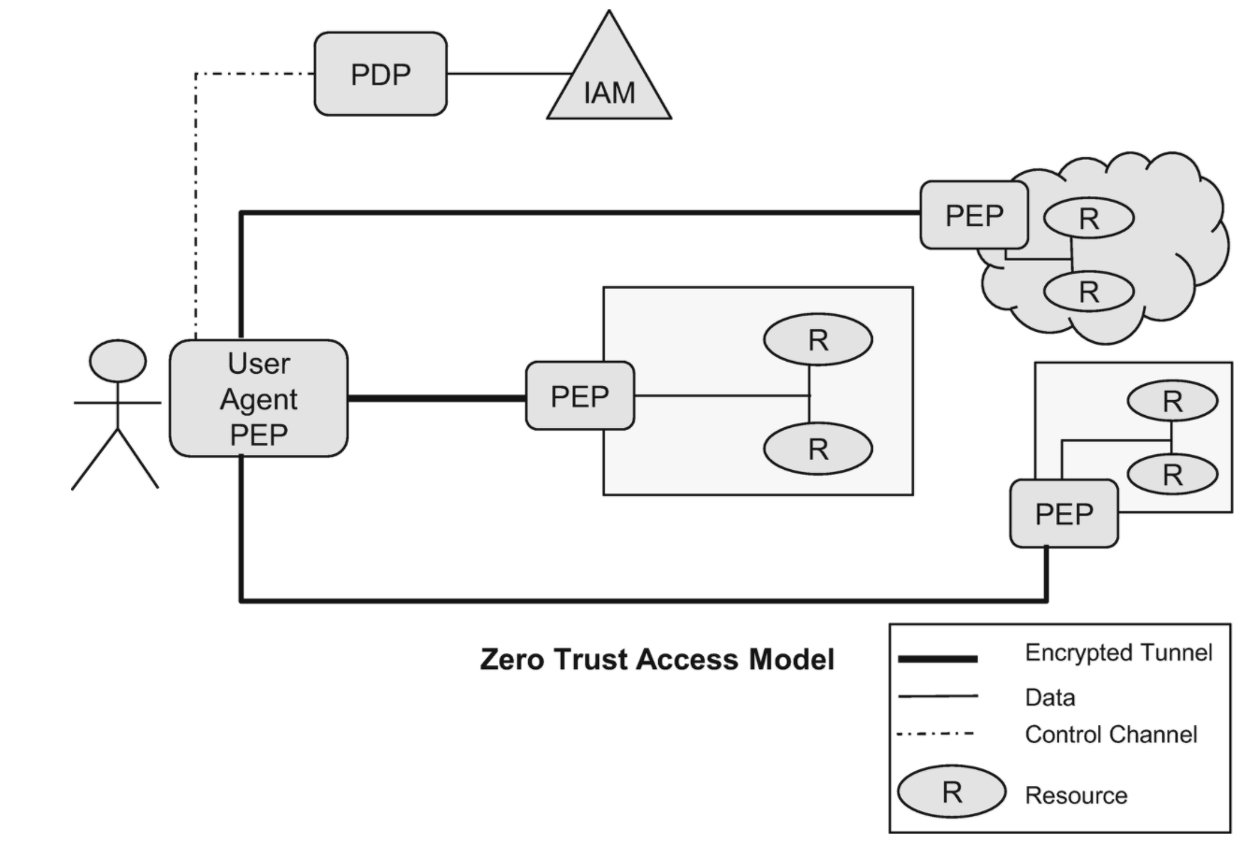
Figure 2: Zero Trust Model PEP distribution [3]
The advantage of this model is that it hides the network entry point from unauthorized users and provides a unified access model that provided a central platform to define and enforce access control policies for all environments [3]. However, encryption of all communication is still critical to guarantee security using Transport Layer Security (TLS) as well as facilitate the removal of privileged network segments or security zones in a network [30].
The management of mobile devices is also a critical element of security. While users work better and increase productivity while feeling more content with the freedom to use their own devices, it poses a security risk that IT teams must address [31]. Endpoints can easily become the weakest link in a Zero Trust strategy. However, with effective mobile device management (MDM), provisioning ensures every device has the appropriate profiles, policies such as encryption and applications including an Endpoint Protection Platform (EPP), Endpoint Detection and Response (EDR) solution and undergoes continuous monitoring to mitigate threats and remediate when they occur. It also provides continuous visibility into device health and compliance status [32]. MDM coupled with an effective network access control ensures that the Zero Trust model limits the damage if a device is compromised. MDM further protects against data loss and leakage through capabilities such as remotely locking or erasing data on a device as well as providing visibility into the behavior of user installed applications. Steve [7] adds that implicit trust between identities, endpoints, and workloads simply because they are on the “inside” is no longer a valid approach. This is more evident today as user authentication is not adequate for protection against modern day threats such as injection attacks, lateral movement, software, and data integrity failures etc.

Industry Players Adoption of the Zero Trust Security Architecture

According to Gartner [33], there are several vendors offering Zero Trust solutions as of 2019 as shown in figure 10 where they provide them as a service from the cloud or a stand-alone offering that the customer is responsible for supporting. Forrester Research [34] also highlighted it’s leading Zero Trust eXtended Ecosystem Platform Providers, Q3 2020 as shown in figure 11 with the implementations for Cisco Systems, Microsoft and Palo Alto Networks highlighted below.
Cisco Systems [35], focuses on Zero trust for the workforce; focusing on users and user devices accessing corporate resources, workplace; focusing on the network access control and workload; focusing on restricting access to workloads and applications based on contextual policy. Microsoft [36], on the other hand focuses on verifying identity through concepts such as multifactor authentication, verifying devices including both managed and unmanaged devices and verifying access through identity and device health verification for all access methods. Palo Alto Networks [37], focuses on Zero Trust for the users, applications and infrastructure centered around the identity to validate user access, device, or workload to verify device and workload integrity, access to ensure least privilege access and the transaction to ensure no malicious activity or data theft.
While each vendor has a different solution offering, the foundational elements in each product ensure a critical review of how users and devices are authenticated and authorized, how applications are accessed and behave, and how they communicate and share data with each other. Different organizations such as Gartner Corporation evaluate and conduct independent research on different technologies and classify vendors based on the effectiveness of their solutions.

Parameters to Measure Zero Trust
Evan and Dough [20] define that Zero Trust is built on these principles:
• The network is always assumed to be hostile.
• There always exist internal and external threats in the network.
• Network locality is a sufficient determination of trust in the network
• Every user, device and network flow are authenticated and authorized.
• Policies must be dynamic and calculated from many data sources.
Considering these principles, Gartner [33], provides the following capabilities as a measure of Zero Trust on the network, identities, and endpoints: Identity-based schema, resource secure access, continuous trust evaluation and adaptive access control. Identity-based schema provides a digital identity to elements in the network that is necessary to provide the least privilege access for subjects. Resource secure access requires encryption of all traffic including application traffic and API calls with high intensity TLS and recommends the use of a domestic cipher algorithm to encrypt and decrypt data. Continuous trust verification ensures a constant assessment of the context environment for any risks and identifies any abnormal access behavior and adjust the result of trust evaluation. Adaptive access control recommends the use of Role Based Access Control (RBAC) and Attribute Based Access Control (ABAC) to attain flexible access controls baselines. RBAC grants access based on roles while ABAC grants access based on characteristics of the user, resource, or environment [38].
These capabilities ensure encryption, authentication, and enforcement of all untrusted access requests based on the digital identity of all participating elements in the network. They aggregate data from a variety of sources to ensure continuous trust verification and dynamic permission enforcement based on the subject’s trust levels to establish an adaptive trust relationship between the access subject and access object.

Conclusion
This study signifies the important of adopting the Zero Trust security model to improve the efficacy of security in the network by enabling organizations to mitigate, detect and respond to risks. However, as with any new technology, Zero Trust opens avenues for new threats and challenges [9]. At the core of the ZTA is the PDP and PEP that can be targeted with distributed denial of service (DDoS), supply chain attacks or route hijacking [9]. Corrupting PDP would impact how access is granted or denied. Measures such as deploying PDP in a secure cloud environment can mitigate this. In addition, among cloud providers, there may be vendor lock in and interoperability issues that may hinder deployment of ZTA [9]. This can be countered by using vendor solutions with open APIs for integrations, supporting standards and protocols that allow for device interoperability [9].
ZTA is a new concept, and its adoption is a journey rather than a wholesale replacement of infrastructure or processes. As a result, many challenges may continue to exist. An organization should seek to incrementally implement zero trust principles, process changes, and technology solutions that protect its highest value data assets. Most enterprises will continue to operate in a hybrid zero-trust or perimeter-based mode for an indefinite period while continuing to invest in ongoing IT modernization initiatives. Having an IT modernization plan that includes moving to an architecture based on Zero Trust principles may help an enterprise form roadmap for workflow migrations to ensure a smooth transition [9].

Chapter 3

Research Methodology

Introduction
Research methodology is defined as a set of activities used to unearth knowledge that seeks to answer specific issues or questions [39]. This chapter outlines the research design and data collection methods, target population and system design methodology that incorporates the system architecture, design, development, implementation and testing of the predictive model application.

Research Design
The research design process is used to depict how the researcher collected data to address the research questions [40]. It is the conceptual structure within which research is conducted and consists of the blueprint for the collection, measurement, and analysis of data [40]. This research leveraged the quantitative research approach with surveys being the primary research method. Quantitative research uses deductive reasoning and utilizes quantitative analysis techniques that can provide a description of the variables and establish statistical relationships among variables through statistical modelling [41]. The results are subjected to statistical treatment to support or refute the research hypothesis [42]. It utilizes and analyzes numerical data using specific statistical techniques to answer questions like who, how much, what, where, when, how many, and how [43].
The survey was administered using questionnaires whose responses provided primary data regarding the security measures and techniques in play in Kenyan financial institutions to mitigate threats. This enabled the identification of the stage they are in in Zero Trust adoption, the SDN architectures implemented and the measures and techniques in place to mitigate and handle new threats in the current landscape. The stage in the Zero Trust adoption was the Y variable in the research while X variables were represented by the values of the questions on the SDN architectures and measures and techniques in place to mitigate threats. In research, the Y variable also known as the dependent variable is one that changes based on the values of the X or independent variable [44]. The X variable also known as independent variable affects the value of another variable [45].

Target Population
The target population is the total group of individuals or elements from which the sample is drawn [41]. Researchers use sampling to gather information about the population of interest and draw inferences about the population. In this research, the population comprises of organizations playing in the Kenyan financial market that include local and foreign banks, insurance companies and savings and credit cooperative organizations (SACCOs). As of 2020, Central Bank of Kenya [45] acknowledges that there are 25 local banks and 15 foreign banks that are privately owned, 3 publicly owned banks and 14 microfinance banks that are regulated by the Central Bank of Kenya. As of 2016, the Insurance Regulatory Authority of Kenya [46] listed 55 licensed insurance companies in Kenya. For the financial year ending December 2022, the Sacco Societies Regulatory Authority (SASRA) [47] licensed 185 deposit taking Sacco’s. This results to a population size of 297 financial institutions.

Sampling
In quantitative research, it may not be possible to study the entire population and hence the use of a sampling to select a subset of the population known as a sample [41]. There are different probability sampling methods available that include simple random sampling, systematic random sampling, stratified random sampling and cluster sampling [41]. This research study uses stratified random sampling as it involved three different groups in the population which are banks, insurance companies and SACCOs. The characteristic of the population must be known before the sample is selected in stratified random sampling [48]. In stratified sampling, the characteristic of the population must be known so that the population can be stratified before the sample is selected [48].
To determine the sample size for this study, using a 95% confidence level and 0.05 precision, the following sample size formula was used:
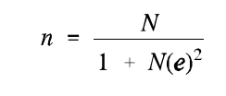
Figure 3: Sample size formula [49]
Where:
n = Required sample size
N = Population size
e = Degree of accuracy or precision (5%)
With a population size of 297 the below calculation results to the sample size required.
n= 297/1+297(0.05) (0.05)
n=170
As recommended by most researchers, this research used a 95% confidence level and a 5% margin of error [50]. The population consisted of 3 groups or strata and required to be stratified to gather the number required per stratum. The sample size for each stratum is proportional to the size of the population [51]. To calculate the stratified random sample the following formula was used as outlined in Table 1.
Sample size of the strata = size of entire sample / population size * stratum size [51]
Where the size of the entire sample =170 and Population size=297

Table 1:Stratum sample size calculation
Institution Type | No. of institutions per stratum | Sample size per stratum
Banks | 57 | 170/297 *57 =33
Insurance | 55 | 170/297 * 55=32
Sacco | 185 | 170/297 *185= 105
The table above represented the distribution of the sample size consisting of 170 questionnaires among the different financial institutions. However, to account for any non-responses given the population of banks and insurance companies as compared to the Sacco population, the questionnaires were administered to the entire population of Banks and insurance companies.

Data Collection
Data collection is process of acquiring information from the subjects under investigation [48]. The questionnaires were administered online to network and system administrators using the Qualtrics platform. The questions were designed with the objective of being quantitative in the form of yes/no and a 5-point Likert scale. The survey was cross-sectional in that the data was collected at a specific point in time from the sample population [48]. The online platform enabled the ease of administration with no costs involved and allowed the capture data from many respondents while allowing for numerous questions to be asked on a given subject. In addition, it enabled the real-time tracking of the number of responses received for efficient research project management.

Ethical Considerations
This research study conformed to the University of York computer science ethics policy with the evidence of fast-track application form submission and approval by the ethics committee. All materials used in this research that were obtained from various sources were acknowledged in text and in the references. Personal data or identifying information was not collected from the participants and only the data collected was used for data analysis. The sensitivity of the security information required during data collection necessitated the need to acquire informed consent by participating institutions and respective network and system administrators before requiring them to participate in the questionnaire [43]. In addition, the respondents were well informed on their role and research scope and had the option to withdraw from the study at any stage in the research process.
This research also anonymized the institutions and individuals participating in the research to ensure the data collected cannot be traced back to an individual or institution. Subsequently, the data collected was stored securely in a password protected folder on Google drive and access provided only to the authorized users.

Chapter 4

System Analysis and Design

Introduction
This chapter elaborates on the approaches used in system analysis, system design, system development and testing. The data collected as outlined in chapter 3 provides data that trains a predictive model used to determine the stage in which financial institutions are in the journey to Zero Trust. In addition, a pickle file generated from the predictive model is plugged into an application that allow users to interact with the model using a graphical user interface. Predictive modeling requires the use of known results to predict the results of a new occurrence.

System Development Methodology
The application was developed using the Software Development Life Cycle (SDLC) waterfall methodology. The waterfall software development methodology is sequential and requires each stage of the life cycle to be completed in its entirety before moving on to the next stage [52]. It comprises of five stages as shown and discussed below:
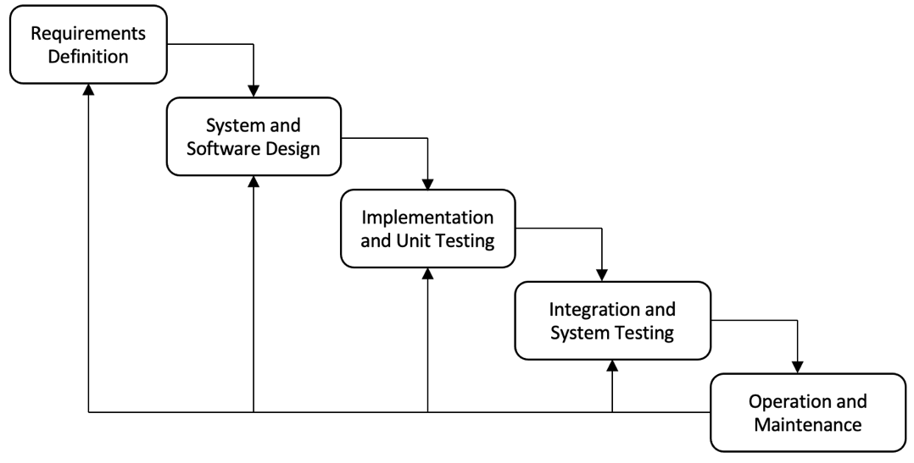
Figure 4: Waterfall model [42]
Ian [50] describes the stages as follows:
- Requirement’s definition: This stage involves gathering system requirements to determine the features required by the predictive model. Users should be able to fill in the questionnaire through the application and the application should be able to predict the stage in Zero Trust adoption in the network, identities, and endpoints
- System and software design: In the design phase, technical design specifications are created. The specifications detail how the requirements will be fulfilled by the solution.
- Implementation and unit testing: This phase represents the actual work of coding. The design specifications are implemented in code.
- Integration and system testing: During this phase, testing is conducted to ensure that the implementation works correctly and that the requirements are fulfilled.
- Operation and maintenance: Once the software has been deployed, the life cycle enters this phase for bug fixes and other enhancements.
The advantage of the waterfall model is that it allows the identification of the system requirements before the design and developments begins hence minimizing any chance of changing requirements as the project progresses. In this research, the project was not large or complex and its requirements were well understood and unlikely to change. In addition, the project was constrained to a fixed timeline making waterfall the most suitable methodology to use.

System Architecture and Design

Requirement’s analysis
Upon creating the predictive model and accepting the null the hypothesis with the results consistent with the null hypothesis, the next step required the creation of a simple application that leveraged the model to predict the Zero Trust adoption maturity of any organization. Therefore, a user requires access to a user interface that allows the user to respond to questions regarding the security measures in place to protect the network, identities, and endpoints. The user interface interacts with the trained predictive model to provide the outcome and recommendations.

System architecture
The system architecture comprises of three components: The user interface, a predictive model service and a database for storing the Zero Trust strategy recommendations as outlined in the figure below.
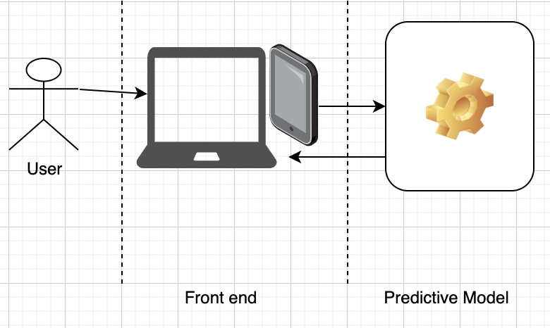
Figure 5:System architecture

System design

System designs provides a comprehensive view on how the various components of the system work using Unified Modelling Language (UML). UML is a standard language for writing software blueprints. The UML may be used to visualize, specify, construct, and document the artifacts of a software-intensive system [53]. The UML diagrams include a use case diagram, sequence diagram and class diagram.

Use case diagram
A use case diagram provides a graphical overview of the functionality provided by the system in terms of actors, who are the stakeholders of the system, their goals represented as use cases and any dependencies between the use cases [54]. The use case diagram for this application is represented below. There are only two actors in the system as this is a simple application to visualize the predictive model.

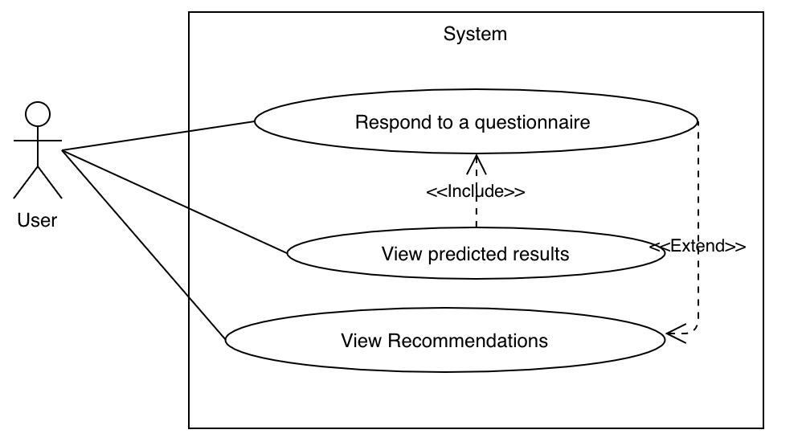
Figure 6:Use case diagram

Sequence diagram

A sequence diagram depicts the interaction between objects arranged in a time sequence [54]. The figures below elaborate on the interaction for a user of the system.

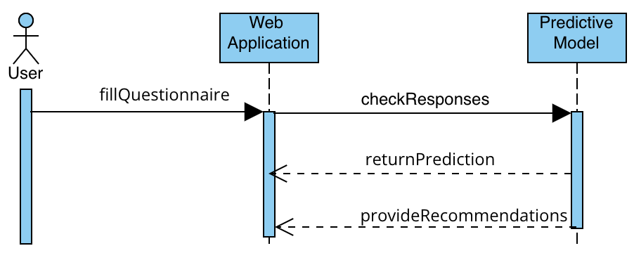
Figure 7:Sequence diagram for the user interactions

Programming Tools
The application was developed using HyperText Markup Language (HTML) and Cascading Style Sheets (CSS) for the front-end user interfaces, Python flask web framework in the backend, and MySQL database. The database is essential to store the questionnaire responses as the data collected can be leveraged to train the model in future. The data collected was used to train a predictive model from which a pickle file was generated and added into the Python application that runs the survey questions for network and system administrators to measure their Zero Trust adoption. Pickle files enable the serialization of Python object structures, which is the process of converting an object in the memory to a byte stream that can be stored as a binary file on disk [55]. When loaded back into a python program, the binary file can be de-serialized back to a Python object.

Chapter 5

Data Analysis, System Implementation and Testing

Introduction
Data analysis is the process of interpreting data collected using analytical and logical reasoning to determine patterns, trends and relationships and draw conclusions [56]. The data analysis incorporated descriptive and inferential statistics. Descriptive statistics provides a summary of the sample characteristics in the research study using graphs, charts, and tables [57]. On the other hand, inferential statistics enable the analysis of the sample population through comparison, testing and prediction of data to derive conclusions about the population as well as test the hypothesis [58].

Survey Responses
Based on the sample size, 170 respondents were required. After the survey administration 127 responses were received. After data cleaning to eliminate null values, there was a total of 121 responses which accounts for 71.2% response rate. Security related information in financial institutions is sensitive and organizations may be skeptical in sharing such data hence justifying the response rate. The pie chart below shows the distribution of the responses received across the different types of financial institutions. There were 57 responses from banks, 39 responses from SACCOs and 25 responses from insurance companies that accounted for 47%, 32% and 21% of responses respectively.
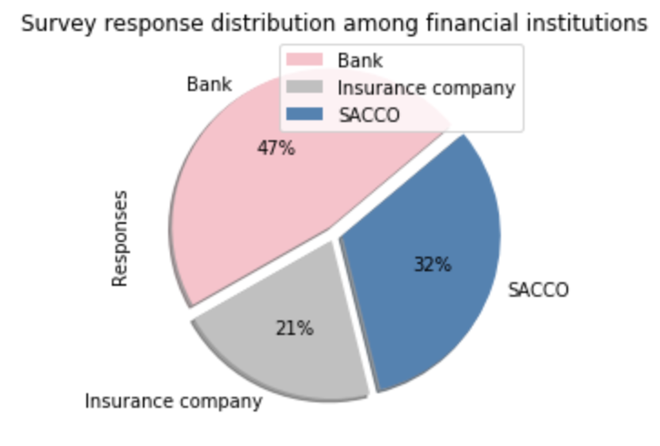
Figure 8:Survey response distribution among financial institutions
The data collected was downloaded from Qualtrics in CSV format and imported into Jupyter Notebook for data cleaning and visualization using Python libraries that include NumPy, Pandas, Matplotlib and Seaborn libraries and Statistical Package for the Social Sciences (SPSS).
Variable selection is required to perform a successful data analysis as it enables the identification of factors highly affect the target and hence determine the most appropriate statistical test to use. The table below describes the variable breakdown.
Table 2: Variable breakdown
Variable Type | Name | Description | Data Type
Target | zt_adoption | Determines the level at which an institution is at on a Zero Trust Scale of 1 to 5. 1 being lowest and 5 being highest. | Likert Interval Scale of 1 to 5. Representable as both continuous and categorical.
Feature | institution | Determines the institution filling the survey. Either bank, SACCO, or Insurance company | Categorical variable with 3 levels.
Feature | sda | Determines the adoption of Software Defined Access/Branch | Binary variable with either Yes or No.
Feature | sdwan | Determines the adoption of Software Defined WAN | Binary variable with either Yes or No.
Feature | sddc | Determines the adoption of Software Defined Data Center | Binary variable with either Yes or No.
Feature | segmentation | Determines the adoption of network segmentation | Binary variable with either Yes or No.
Feature | encryption | Determines the implementation of encryption for all traffic | Binary variable with either Yes or No.
Feature | mfa | Determines the adoption of Multi-Factor Authentication for all users on a scale of 1 to 5. 1 being lowest and 5 being highest. | Likert Interval Scale of 1 to 5. Representable as both continuous and categorical.
Feature | sso | Determines the adoption of Single Sign On for all users | Likert Interval Scale of 1 to 5. Representable as both continuous and categorical.
Feature | policy_engine | Determines the existence of a security policy engine to make decisions on access control | Binary variable with either Yes or No.
Feature | mdm | Determines the use of Mobile Device Management for all devices on a scale of 1 to 5. 1 being lowest and 5 being highest. | Likert Interval Scale of 1 to 5. Representable as both continuous and categorical.
Feature | dlp | Determines the use of Data Loss Prevention on all endoints | Binary variable with either Yes or No.

Summary statistics
Summary statistics provide and summarize information about the sample data through the measures of central tendency [59]. In this research the summary statistics are represented by the table below.
Table 3: Measures of central tendency
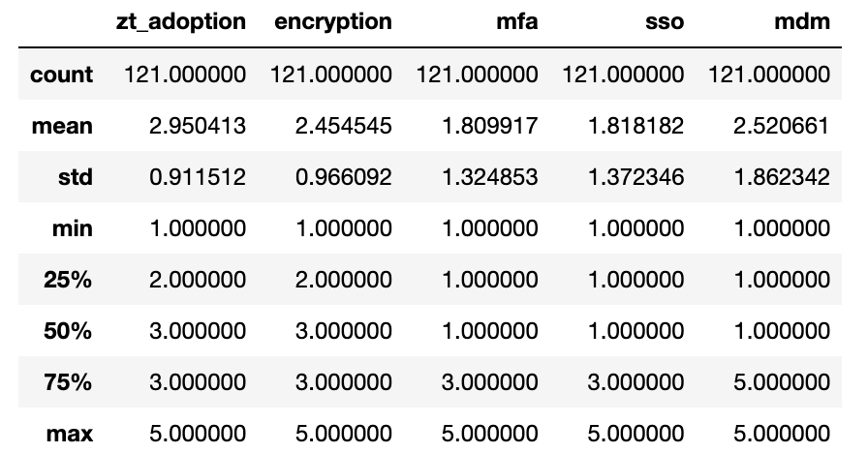
As per the central tendency results, the mean of 2.95 represents a partial adoption of Zero Trust. It also indicates partial adoption of encryption and mobile device management (MDM) in all financial institutions. The standard deviation is a measure of how dispersed the data is in relation to the mean [60]. Low standard deviation signifies that the data is clustered around the mean while a high standard deviation shows that the data is dispersed further from the mean. In the results, the standard deviation on zero trust adoption and encryption is < 1 indicating that majority of the data is clustered around the mean.

Pearson’s Correlation
Pearson correlation checks for the association between continuous variables [60]. The Y variable in the research study was the stage in Zero trust adoption among financial institutions in Kenya. The table below outlines the correlation (Pearson) between the continuous variables.
Table 4: Correlation between continuous variables
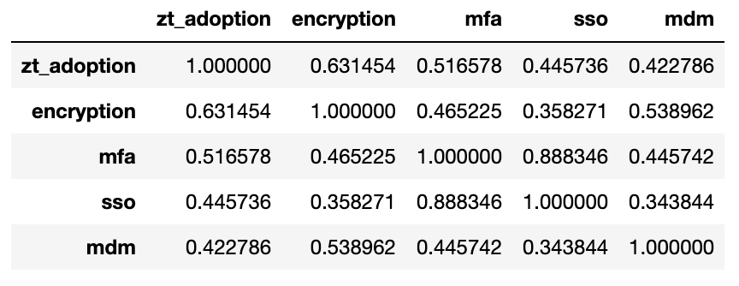
After correlation of the continuous variables, the use of encryption and MFA had a higher correlation with Zero Trust Adoption which is >0.5. Subsequently, as outlined in section 2.8, these capabilities form part of the parameters to measure Zero Trust adoption. MFA and SSO also indicate a very high positive correlation of 0.89. This signifies that majority of the institutions that have adopted MFA also implement SSO. Tayibia and Aqeel [61] argue that combining MFA and SSO enhances user experience and productivity as users spend less time logging into systems.
To further analysis the continuous variables, the sections and visualizations below depict the analysis results to these questions using bar graphs, pie charts and contingency tables.

Respondent’s use of encryption among the different institutions

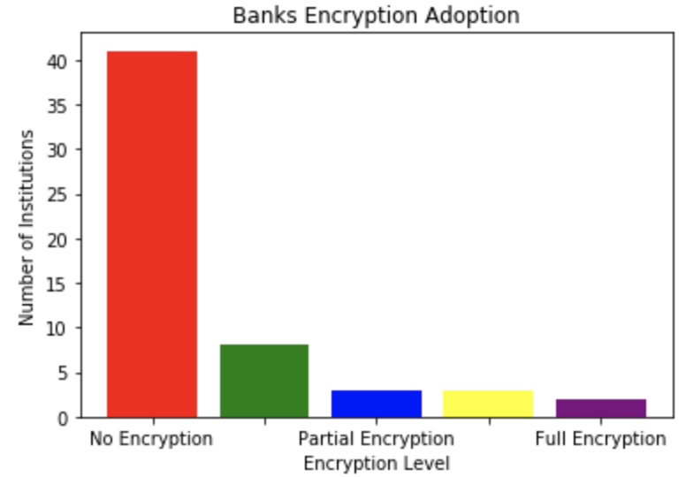
Figure 9:Banks use of encryption level
Figure 11 shows that 82% of the banks have not implemented the use of encryption with less than 1% implementing full encryption. This is a risk indication as Banks should protect themselves against man in the middle attacks and hijacking of sessions by leveraging encryption.
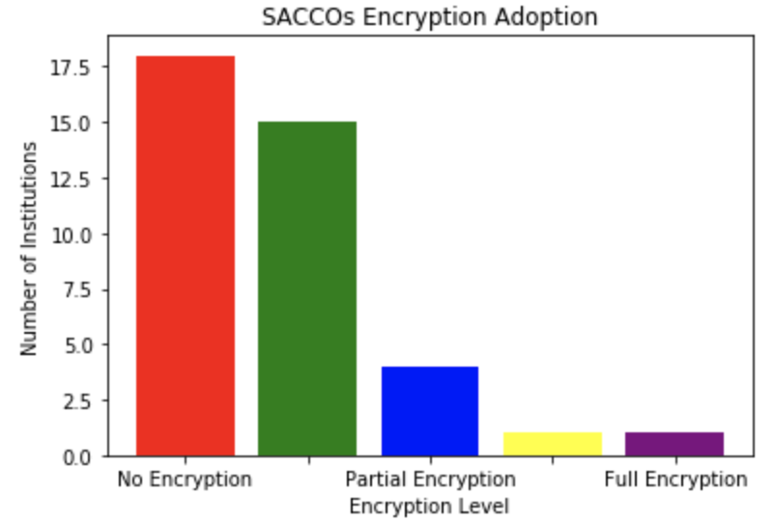
Figure 10:SACCOs use of encryption level
Figure 12 indicates that SACCOs have a 50% of the respondents running no encryption on their network. However, 13.3% have partial encryption while less than 1% have implemented full encryption of network traffic.
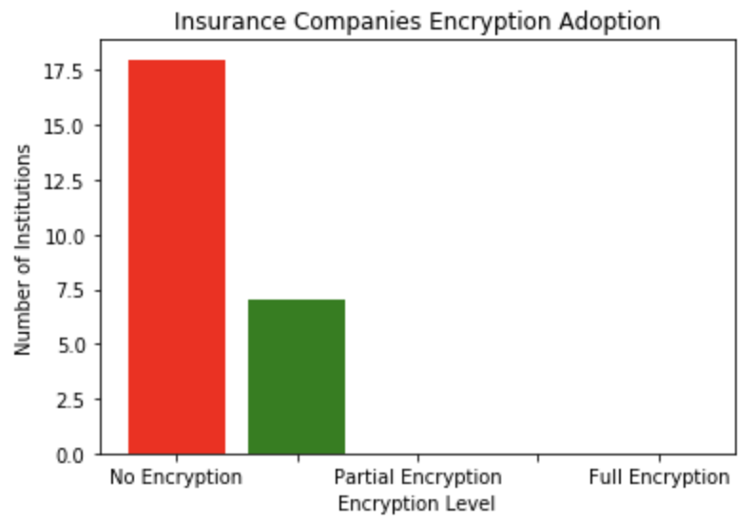
Figure 11:Insurance companies use of encryption level
Figure 13 also shows that majority of the insurance companies enforce no encryption in the network which accounts for 72% of insurance companies.

SDN adoption among financial institutions
Section 2.4 highlights an argument by Evan and Dough [20] that Zero Trust networks require automation systems to be built and operated. The survey questions collected data regarding the adoption of SDN among financial institutions and the results are as shown in the tables below.

Software defined access/branch adoption
Table 5: Software defined access/branch adoption

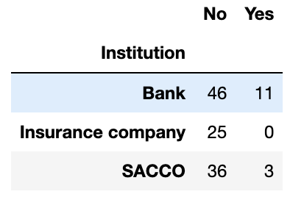

Software defined wide area network
Table 6: SDWAN adoption

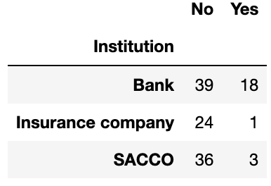

Software defined data center
Table 7: Software defined data center adoption

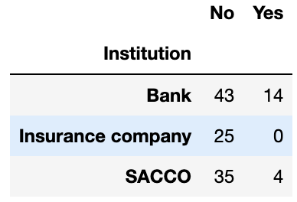

The tables above illustrate that the adoption of SDN among financial institutions is low with around 44% of institutions having implemented some form of SDN technology. Subsequently, there is more adoption of SDWAN as compared to other SDN technologies.
A correlation of the level of Zero Trust adoption and software defined networking adoption depicts that financial that adopt SDN have higher level of Zero trust adoption as compared to those with no software defined networking adoption. This is illustrated in the graphs below for the different software defined technologies.
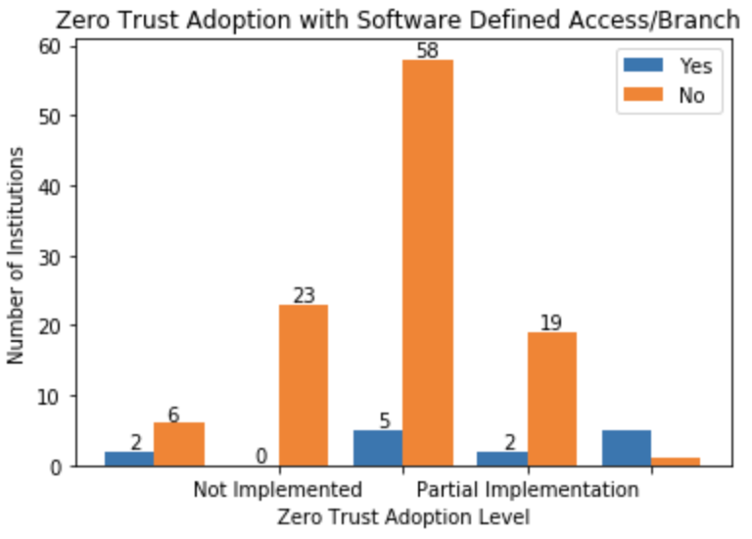
Figure 12:Zero trust adoption with software defined access/branch
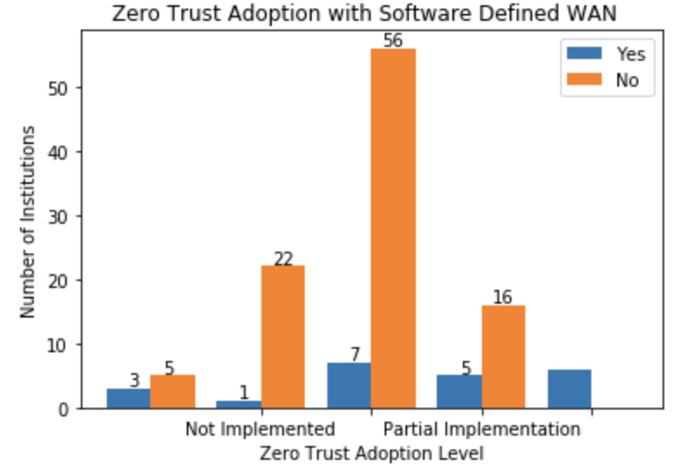
Figure 13:Zero Trust adoption with software defined wide area network
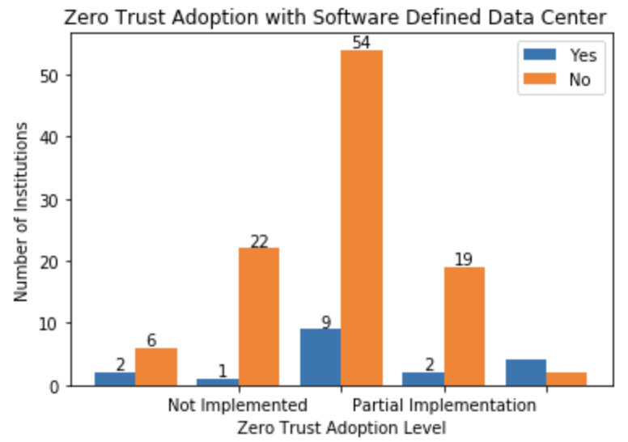
Figure 14:Zero Trust adoption with software defined data center

Network segmentation adoption among financial institutions

Network segmentation and micro segmentation is a key piece to Zero Trust as it prevents lateral movement in the event of compromise by creating perimeters of control around sensitive data [3]. Figure 17 below shows the network segmentation adoption among financial institutions in Kenya.
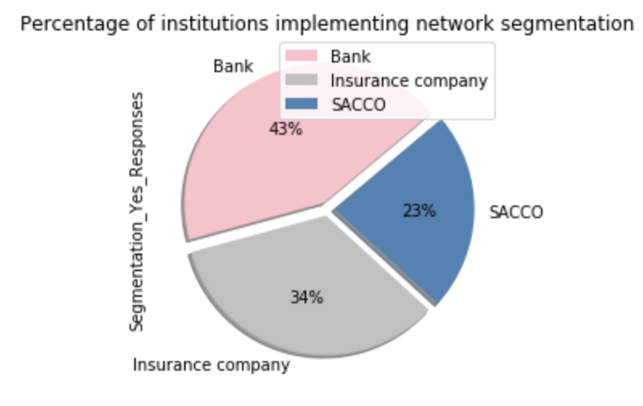
Figure 15:Percentage of institutions implementing network segmentation

Use of security policy engine for access control among financial institutions

Zero Trust requires authentication, authorization and continuous verification of all users and devices accessing the network [17]. From the responses gathered, 52% of banks, 21% of insurance companies and 27% of SACCOs rely on a policy engine to make access decisions as shown in figure 18 below.
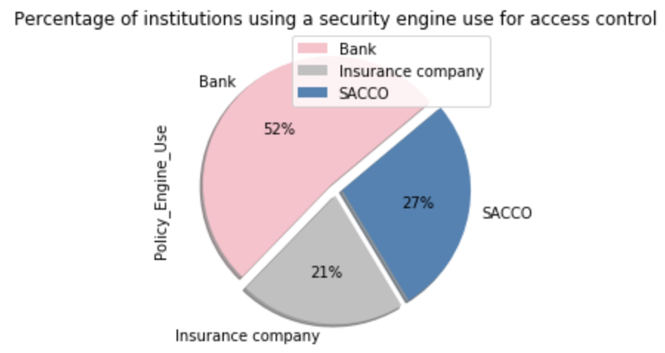
Figure 16:Percentage of institutions using a security engine use for access control

Use of MDM updates among financial institutions
Mobile Device Management (MDM) is required in addition to MFA and SSO as it provides control by applying and ensuring a pre-defined configuration of all devices in use in an organization [62]. The figures below show the adoption of MDM in the different institutions and indicate that 65% of banks,85% of SACCOs and 88% have not implemented any MDM.

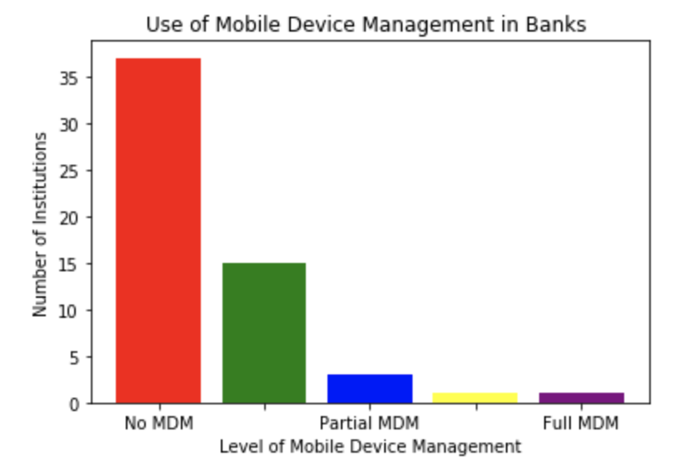
Figure 17:Use of Mobile Device Management in Banks
Banks
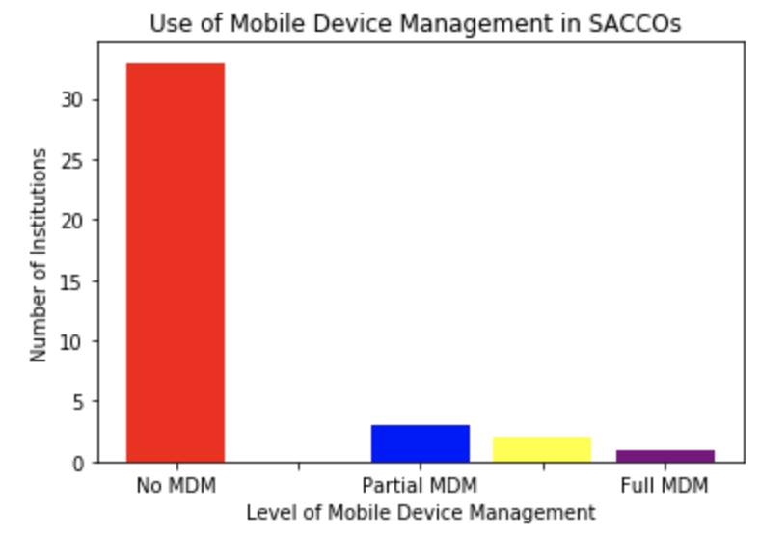
Figure 18:Use of Mobile Device Management in SACCOs
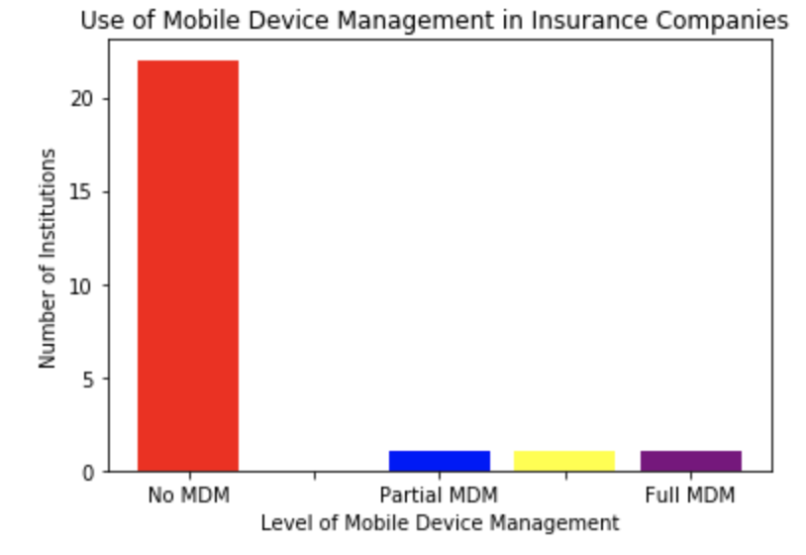
Figure 19:Use of Mobile Device Management in Insurance Companies

Use of Data Loss Prevention for Endpoints
Data loss prevention (DLP) is essential in a Zero Trust network as it guards against zero-day attacks by providing information that allows for continuous real time monitoring of endpoints to prevent leakage of sensitive data [63]. Figure 22 shows the percentage of institutions using DLP.

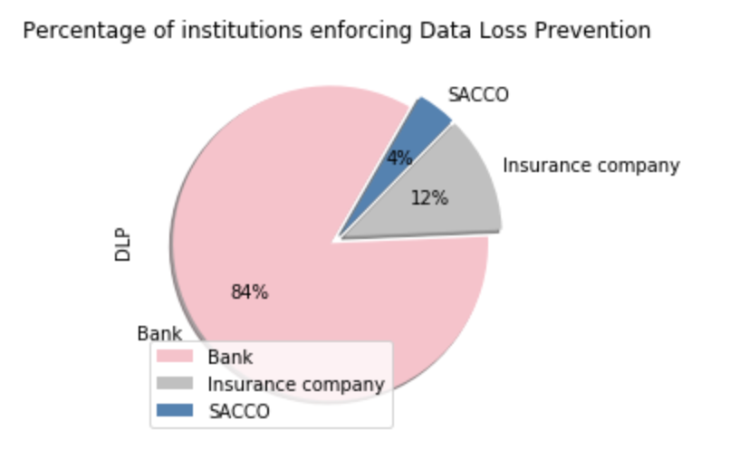
Figure 20:Institutions using Data Loss Prevention

Inferential Statistics
Inferential statistics generalizes the larger population based on a representative sample of that population by making predictions and presenting results in form of a probability [58]. The data collected represents a section of the population and incurs a sampling error hence not expected to represent the population accurately [58]. The methods of inferential statistics include the estimation of parameters and testing of statistical hypotheses [58].

Statistical Test Validation
The data collected shows that the dependent variable is an ordinal interval scale, and the independent variables are either continuous or categorical. Therefore, the most appropriate statistical test is Ordinal Logistic Regression (OLR). OLR predicts an ordinal dependent variable given one or more independent variables [64]. It assumes the following [64]:
- The dependent variable should be an ordinal interval scale.
- The independent variables should be either continuous or categorical.
- There is no multicollinearity on the independent variables and the type of ordinal independent variable is the same. No multicollinearity on the independent variables ensures that no two independent variables are highly corelated.
- The type of ordinal independent variable should be the same and the dependent variable ratio should be low.

Chi-Square Test (Person’s) for independence
In inferential statistics, the chi-square test checks for a relationship between two categorical variables [60] and addresses assumption 3 above. The figure below shows the results of this test on the data collected.
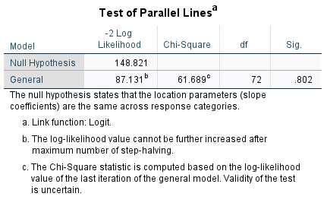
Figure 21:Chi-Square test results
Running the test of parallel lines (Chi-Square test), shows that the significance value (0.82) is greater than 0.05. This means that the Chi-Square value is insignificant and would justify disassociation of the independent categorical variables. This justifies that assumption 3 passes and the OLR statistical test can proceed.

Hypothesis testing using Ordinal Logistic Regression (OLR)

This dataset is used to determine the Zero Trust adoption stage given eleven exogenous variables. The Ordinal Logical Regression can be defined as:
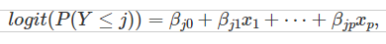 where Bj0, Bj1…...Bjp are model coefficient parameters (i.e., intercepts and slopes) with predictors for j1, j2......, j-1 [65]. Below is the output for the ordinal logistic regression statistical test using the Python statsmodels.miscmodels.ordinal_model.OrderModel.
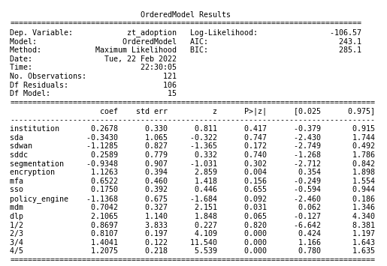
Figure 22:Ordinal Logistic Regression test results

Interpretation on Statistical Inference on Hypothesis
The data in the figure above shows a proportion odd ratio from the coefficients lying between +-1 of each other. This then fulfills the assumption number 4 in section 5.3.1 and justifies the use of OLR. The individual feature variables imply the following:
- For institutions who did not adopt sdcc, the odds of partially or fully implementing the Zero Trust security architecture versus not implementing is 0.343 times those who have implemented sdcc.
- For institutions who did not adopt mfa, the odds of partially or fully implementing the Zero Trust security architecture not implementing is 0.6522 times those who have implemented mfa.
- For institutions who adopted mdm, the odds of partially or fully implementing the Zero Trust security architecture versus not implementing is 0.704 times those who did not implement mdm.
This presents the predictive model that determines the stage financial institutions in Kenya are in their Zero Trust adoption journey. The OLR model is represented as follows:
Log(y)=institution(0.27)+sddc(0.26)+encryption(1.13)+mfa(0.65)+sso(0.18)+mdm(0.70)+dlp(2.11)-sda(0.34)-sdwan(1.13)-segmentation(0.93)-policy_engine(1.14)

System Implementation and Testing

Currently working on it (In progress

Chapter 6

Summary, Conclusion and Recommendations

Research Summary
The literature review provided sufficient evidence that end-to-end security is critical in the operation of any organization and even more critical in financial institutions. However, malicious players are evolving in the way they attack networks, systems, and applications even as technology evolves. In addition, threats are also increasing in sophistication making them harder to identify and track. As a result, a more comprehensive approach to security is required that ensures that no element inside or outside the network is trusted and the network, user and device is considered hostile and compromised.
The comprehensive approach to security is adequately provided for in the Zero Trust security architecture through recommendations around the network, identities, and endpoints on adoption of MFA, Single Sign On (SSO) and identity and access management for users and devices, network segmentation and encryption of all network traffic as well as MDM and Data Loss Prevention (DLP).
The data collected allowed for the creation of a predictive model that organizations can use to assess their level of implementation of the Zero trust architecture and gather feedback via an application on additional security capabilities to adopt to improve on their Zero Trust adoption.

Conclusion
This research investigated the Zero Trust Security Strategy adoption among financial institutions in Kenya. It identified the security techniques and measures in place as recommended in the Zero Trust security architecture. In addition, it identified the adoption of software defined networking in the access or branch, Wide Area Network (WAN) and data center and correlates SDN to Zero Trust adoption level.
This research discovered that for institutions that have implemented encryption, MFA, SSO, SDDC, MDM and DLP, they are more likely to have partially or fully implemented Zero Trust security architecture. It also provided a predictive model that financial institutions can leverage to test the stage they are in in the journey to a Zero Trust architecture.

Recommendations on future work
The Zero Trust security architecture covers the aspects of networks, identities, endpoints, infrastructure, applications or workloads and data. This research focused on networks, identities, and endpoints. Further research can be done on Zero Trust adoption in applications or workloads, data, and infrastructure. This research focused on financial institutions in Kenya only and can be built on by researching on the Zero Trust adoption in other countries and other industry verticals.
There are challenges being experienced by different organizations hindering the adoption of Zero Trust security framework. A research by Dimensional Research published in securitymagazine.com [64] highlights that Covid 19 resulted to remote working and identity and privilege management remains a key challenge that requires adequate planning while migrating to Zero Trust. While this paper highlights on the challenges of vendor lock in and interoperability issues, additional research can be done on other factors hindering migration to a Zero Trust security architecture and how they can be mitigated to facilitate faster Zero Trust adoption.

Appendices

Appendix A
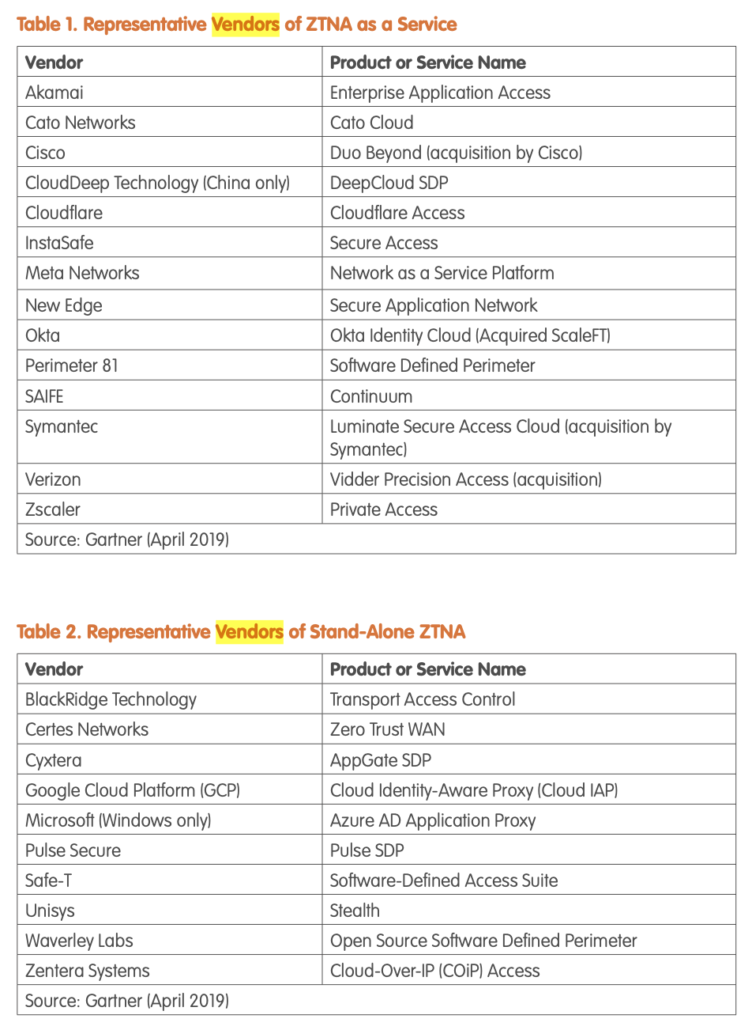
Figure 23: Zero Trust vendors (Gartner 2019)[32]

Appendix B
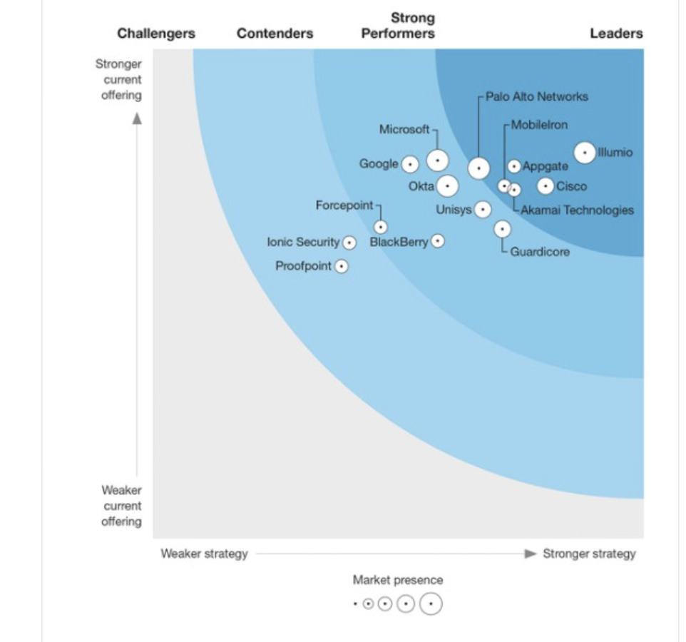
Figure 24:Forrester Wave Zero Trust eXtended Ecosystem Platform Providers, Q3 2020 [33]

Appendix C

Survey Questions
Implementing the Zero Trust Security Architecture in Enterprise Networks in Kenya
Q1 Which type of financial institution do you belong to from the options below?
- Bank
- Insurance company
- SACCO

Q2 Zero Trust is a security framework requiring all users, whether in or outside the organisation’s network, to be authenticated, authorised, and continuously validated for security configuration and posture before being granted or keeping access to applications and data.
At what stage on the scale below is your organisation in the adoption of the Zero Trust Security Architecture?
 | Not implemented | Partially implemented | Fully implemented

 | 1 | 2 | 3 | 4 | 5

select () | 

Q3 Zero Trust networks rely on automation systems such as Software Defined Networking (SDN) to be built and operated. Have you implemented the SDN technologies listed below?
 | Yes (1) | No (2)
a) Software defined Access/Branch
b) Software defined WAN
c) Software defined Data Center
Q4 Are your networks segmented to prevent lateral movement?
- Yes
- No

Q5 On a scale of 1 to 5, do you encrypt all your network communication (including machine to machine) using certificates?
 | No encryption | Partial encryption | Full encryption

 | 1 | 2 | 3 | 4 | 5

Select ()

Q6 Have you enabled multifactor authentication (MFA) for all users?
 | No MFA | Partial MFA (Some users) | Full MFA (All users)

 | 1 | 2 | 3 | 4 | 5

Select ()

Q7 Have you provisioned for single sign on (SSO) for all users?
 | No SSO | Partial SSO (Some users) | Full SSO (All users)

 | 1 | 2 | 3 | 4 | 5

Select ()

Q8 Do you have security policy engine(s) in place to make access decisions for enterprise resources?
- Yes
- No

Q9 Are devices enrolled in mobile device management for all internal users?
 | No MDM | Partial MDM | Full MDM

 | 1 | 2 | 3 | 4 | 5

Select ()

Q10 Do you enforce data loss prevention policies on all managed and unmanaged devices?
- Yes
- No

Abbreviations
BYOD Bring Your Own Device
IOT Internet of Things
GDPR General Data Protection Regulation
CICD Continuous Delivery or Continuous Deployment
API Application Programming Interface
ZTNA Zero Trust Network Architecture
VPN Virtual Private Network
LAN Local Area Network
IPS Intrusion Prevention System
IDS Intrusion Detection System
ZTX Zero Trust Extended
ZTA Zero Trust Architecture
PEP Policy Enforcement Point
PDP Policy Decision Point
CDM Continuous Diagnostics and Mitigation
PKI Public Key Infrastructure
SDN Software Defined Networking
PCI DSS Payment Card Industry Data Security Standard
DDoS Distributed Denial of Service
HTML HyperText Markup Language

References
- J. Andress and S. Winterfield, Cyber Warfare: Techniques, Tactics and Tools for Security Practitioners, 2nd ed. Syngress, 2013. [Online]. Available: https://learning.oreilly.com/library/view/cyber-warfare-2nd/9780124166721/
- R. Halliday, Forrester Data Global Business Technographics Security Survey, 2017: Overview, Forrester Research, Dec. 2017. [Online]. Available: https://www.forrester.com/report/Forrester-Data-Global-Business-Technographics-Security-Survey-2017-Overview/RES141182
- J. Garbis and J. W. Chapman, Zero Trust Security: An Enterprise Guide, Apress, 2021. [Online]. Available: https://www.researchgate.net/publication/349659321_Zero_Trust_Security_An_Enterprise_Guide
- European Commission, Data Protection in the EU. [Online]. Available https://ec.europa.eu/info/law/law-topic/data-protection/data-protection-eu_en
- E. Lannopollo, The Future Under The GDPR, Forrester Research, Feb. 1, 2018. [Online]. Available: https://www.forrester.com/what-it-means/ep49-future-under-gdpr/
- B. Cameron and A. Bartels, How to Adjust Your Tech Budget to Survive or Thrive in The Pandemic Recession, Forrester Research, May 19, 2020. [Online]. Available: https://www.forrester.com/blogs/how-to-adjust-your-tech-budget-to-survive-or-thrive-in-the-pandemic-recession/
- S. Turner, Zero Trust Is Not A Security Solution; It’s A Strategy, Forrester Research, Feb. 18, 2021. [Online]. Available: https://www.forrester.com/blogs/zero-trust-is-not-a-security-solution-it-is-a-strategy/
- A. Deshpande, A Study on Rapid Adoption of Zero Trust Network Architectures by Global Organizations Due to COVID-19 Pandemic, 2021. [Online]. Available: https://www.researchgate.net/publication/353946808_A_Study_on_Rapid_Adoption_of_Zero_Trust_Network_Architectures_by_Global_Organizations_Due_to_COVID-19_Pandemic
- S. Teerakanok, T. Uehara and A. Inomata, “Migrating to zero trust architecture: Reviews and challenges,” Security and Communication Networks, vol. 2021, 2021. [Online]. Available: https://www.researchgate.net/publication/351879191_Migrating_to_Zero_Trust_Architecture_Reviews_and_Challenges
- B. Gardner and V. Thomas, Building an Information Security Awareness Program: Defending Against Social Engineering Hacks and Technical Threats. Elsevier, 2014. [Online]. Available: https://www.sciencedirect.com/book/9780124199675/building-an-information-security-awareness-program
- Google, A new approach to China, Jan 12. 2010. [Online]. Available: https://googleblog.blogspot.com/2010/01/new-approach-to-china.html
- C. Cunninghum, A Look Back at Zero Trust: Never Trust, Always Verify, Forrester Research, Aug. 2020. [Online]. Available: https://www.forrester.com/blogs/a-look-back-at-zero-trust-never-trust-always-verify/
- S. Rose, O. Borchert, S. Mitchell, and S. Connelly, Special Publication 800-207: Zero Trust Architecture, National Institute of Standards and Technology, Gaithersburg, MD, USA,2020. [Online]. Available: https://nvlpubs.nist.gov/nistpubs/SpecialPublications/NIST.SP.800-207.pdf
- J. Kindervag, Build security into your network’s DNA: The zero-trust network architecture. Forrester Research Inc, pp.1-26. [Online]. Available: https://www.forrester.com/report/Build-Security-Into-Your-Networks-DNA-The-Zero-Trust-Network-Architecture/RES57047
- P.Grassi, M. Garcia, and J. Fenton, Digital Identity Guidelines, 2017. NIST Special Publication (SP) 800-63-3. [Online]. Available: https://nvlpubs.nist.gov/nistpubs/SpecialPublications/NIST.SP.800-63-3.pdf
- A. Deshpande, Analyzing the Deployment of Zero Trust Network Architecture in Enterprise Networks, 2021. [Online]. Available: https://www.researchgate.net/publication/354074452_Analyzing_the_Deployment_of_Zero_Trust_Network_Architecture_in_Enterprise_Networks
- D. Home and S. Nair, Introducing Zero Trust by Design: Principles and Practice Beyond the Zero Trust Hype,2021. [Online]. Available: https://www.researchgate.net/publication/353324913_Introducing_Zero_Trust_by_Design_Principles_and_Practice_Beyond_the_Zero_Trust_Hype
- J. Mutch and B. Anderson, Preventing Good People from Doing Bad Things: Implementing Least Privilege, Apress, 2011. [Online]. Available: https://learning.oreilly.com/library/view/preventing-good-people/9781430239215/
- P. A. Morreale and J. M. Anderson, Software Defined Networking: Design and Deployment, CRC Press, 2014. [Online]. Available: https://learning.oreilly.com/library/view/software-defined-networking/9781482238631/
- E. Gilman and D. Barth, Zero Trust Networks: Building secure systems in untrusted networks, O'Reilly Media, Inc., 2017. [Online]. Available: https://learning.oreilly.com/library/view/zero-trust-networks/9781491962183/
- P. Goransson, C. Black and T. Culver, Software Defined Networks: A comprehensive approach, Morgan Kaufmann, 2016. [Online]. Available: https://learning.oreilly.com/library/view/software-defined-networks/9780128045794/
- N. Timms, Security for Software Defined Networks, Pearson, 2014. [Online]. Available: https://learning.oreilly.com/videos/security-for-software/9780133888713/
- R. Sharma, “A Review on Software - Defined Networking,” IJSR CSEIT, vol. 7, no. 2, March 2021. [Online]. Available: https://www.researchgate.net/publication/350115478_A_Review_on_Software_Defined_Networking
- J. C. Chica, J. C. Imbachi and J. F. Vega, “Security in SDN: A comprehensive survey,” Journal of Network and Computer Applications, vol. 159, June, 2020. [Online]. Available: https://www.sciencedirect.com/science/article/pii/S1084804520300692
- A. L. Aliyu, A. Aneiba, M. Patwary and P. Bull, “A trust management framework for Software Defined Network (SDN) controller and network applications,” Computer Networks, vol. 181, Nov. 2020. [Online]. Available: https://www.sciencedirect.com/science/article/pii/S1389128620311105
- A. Anderson (2020, Mar. 2). Microsoft identity acronyms—what do they mean and how do they relate to each other? Microsoft. [Online]. Available: https://www.microsoft.com/security/blog/2020/03/02/microsoft-identity-acronyms-what-they-mean-how-they-relate/#:~:text=Let's%20start%20with%20what%20identity,Multi%2DFactor%20Authentication%20or%20MFA.
- Cisco Systems. Identity Based Networking Services. [Online]. Available: https://www.cisco.com/c/en/us/products/ios-nx-os-software/identity-based-networking-services/index.html
- S. Boonkrong, Authentication and Access Control: Practical Cryptography Methods and Tools, Apress, 2020. [Online]. Available: https://learning.oreilly.com/library/view/authentication-and-access/9781484265703/
- S. Potbhare, “The Need for Continuous Authentication,” Infosecurity Magazine, Nov. 2020. [Online]. Available: https://www.infosecurity-magazine.com/opinions/need-continuous-authentication/
- T. Olzak, Achieve a Zero Trust Network with a Software Defined Perimeter, 2019. [Online]. Available: https://www.researchgate.net/publication/334807716_Achieve_a_Zero_Trust_Network_with_a_Software_Defined_Perimeter
- BCS, The Chartered Institute for IT, Bring your Own Device: The Mobile Computing Challenge, BCS Learning & Development Limited, 2013. [Online]. Available: https://learning.oreilly.com/library/view/bring-your-own/9781780171890/
- P. Mayfield and C. Taylor (2020, May. 26). Zero Trust Deployment Guide for Devices. Microsoft. [Online]. Available: https://www.microsoft.com/security/blog/2020/05/26/zero-trust-deployment-guide-for-devices/
- Gartner. Zero Trust Architecture and Solutions, 2019. [Online]. Available: https://www.gartner.com/teamsiteanalytics/servePDF?g=/imagesrv/media-products/pdf/Qi-An-Xin/Qi-An-Xin-1-1OKONUN2.pdf
- C. Cunninghum, The Forrester Wave™: Zero Trust eXtended Ecosystem Platform Providers, Q3 2020, Forrester Research, Sept. 2020. [Online]. Available: https://www.forrester.com/report/The-Forrester-Wave-Zero-Trust-eXtended-Ecosystem-Platform-Providers-Q3-2020/RES157494
- Cisco Systems. Cisco Zero Trust Security. [Online]. Available: https://www.cisco.com/c/en/us/products/security/zero-trust.html
- Microsoft. Transitioning to modern access architecture with Zero Trust. [Online]. Available: https://www.microsoft.com/en-us/insidetrack/transitioning-to-modern-access-architecture-with-zero-trust#:~:text=Microsoft%20has%20adopted%20a%20modern,of%20identities%2C%20devices%20and%20services.
- Palo Alto Networks. The Zero Trust Enterprise. [Online]. Available: https://www.paloaltonetworks.com/zero-trust
- S. M. Thampi, B. Bhargava and P. K. Atrey, Managing Trust in Cyberspace, Chapman and Hall/CRC, 2013. [Online] Available: https://learning.oreilly.com/library/view/managing-trust-in/9781466568457/
- E. Savarit, Practical User Research: Everything You Need to Know to Integrate User Research to Your Product Development, Apress, 2020. [Online] Available: https://learning.oreilly.com/library/view/practical-user-research/9781484255964/
- C. R. Kothari, Research Methodology, Methods & Techniques, New Age International Publishers, 2004.
- K. Khalid, “Get Along with Quantitative Research Process,” International Journal of Research in Management, vol. 2(2), 2012. [Online]. Available: https://www.researchgate.net/publication/259359212_GET_ALONG_WITH_QUANTITATIVE_RESEARCH_PROCESS
- O. D. Apuke, “Quantitative Research Methods: A synopsis approach,” Arabian Journal of Business and Management Review, vol. 6(10), 2017. [Online]. Available: https://www.researchgate.net/publication/320346875_Quantitative_Research_Methods_A_Synopsis_Approach
- C. W. Dawson, Projects in Computing and Information Systems : A student's guide, Pearson Prentice Hall, 2009.
- S. Shukla, Variables, Hypotheses and Stages of Research 1, 2018. [Online]. Available: https://www.researchgate.net/publication/325127119_VARIABLES_HYPOTHESES_AND_STAGES_OF_RESEARCH_1
- Central Bank of Kenya, “Bank supervision,” [Online]. Available: https://www.centralbank.go.ke/bank-supervision/
- Insurance Regulatory Authority, “Licensed insurers,” [Online] Available: https://www.ira.go.ke/index.php/licenced-insurers
- Sacco Societies Regulatory Authority, “List of sacco societies licensed to undertake deposit-taking sacco Business in Kenya for the financial year ending December, 2021,” [Online] Available: https://www.sasra.go.ke/download/list-of-licensed-and-authorised-sacco-societies-in-kenya-for-the-financial-year-ending-31st-december-2022/
- J. W. Creswell, Research Design: Qualitative Quantitative and Mixed Methods approaches, 4th Ed. Sage Publication, 2014.
- University of Florida, Determining Sample Size. [Online]. Available: https://www.tarleton.edu/academicassessment/documents/samplesize.pdf
- H. Taherdoost, “Determining Sample Size; How to calculate survey sample size,” International Journal of Economics and Management Systems, vol. 2 pp. 237-239, 2017. [Online]. Available: https://www.researchgate.net/publication/322887480_Determining_Sample_Size_How_to_Calculate_Survey_Sample_Size
- S. Glen. "Stratified Random Sample: Definition. [Online]. Available: https://www.statisticshowto.com/probability-and-statistics/sampling-in-statistics/stratified-random-sample/#:~:text=The%20sample%20size%20for%20each,%2F%20population%20size%20*%20layer%20size.
- J. Ingeno, Software Architect's Handbook, Packt Publishing, 2018. [Online] Available: https://learning.oreilly.com/library/view/software-architects-handbook/9781788624060/
- I. Sommerville, Software Engineering, 10th Ed. Pearson, 2016.
- S. Bennett, S. McRobb and R. Farmer, Object – Oriented System Analysis and Design using UML, 4th Ed. McGraw-Hill Education, 2010.
- Q. Kong, T. Siauw and A. Bayen, Python Programming and Numerical Methods: A Guide for Engineers and Scientists, Academic Press, 2020. [Online]. Available: https://www.elsevier.com/books/python-programming-and-numerical-methods/kong/978-0-12-819549-9
- A. D. Mauro, F. Marzoni and A. J. Walter, Data Analytics Made Easy, Packt Publishing, 2021. [Online] Available: https://learning.oreilly.com/library/view/data-analytics-made/9781801074155/
- S. Sharma, Descriptive Statistics, 2019. [Online]. Available: https://www.researchgate.net/publication/333220406_Descriptive_Statistics
- A. Rashid, Class Lecture, Topic: “Difference between descriptive and inferential Statistics,” NAPD Training Class, Bangladesh University of Professionals , Bangladesh, May, 2021. [Online]. Available: https://www.researchgate.net/publication/351381217_Difference_between_descriptive_and_inferential_Statistics
- S. Glen. " Summary Statistics: Definition and Examples: Definition. [Online]. Available: https://www.statisticshowto.com/summary-statistics/#:~:text=Summary%20statistics%20summarize%20and%20provide,(also%20called%20central%20tendency).
- T. Nield, Statistics for Data Science, 2021. [Online] Available: https://learning.oreilly.com/scenarios/statistics-for-data/9781098111137/
- T. Bazaz and A. Khalique, “A Review on Single Sign on Enabling Technologies and Protocols,” International Journal of Computer Applications, vol. 151(11), 2016. [Online]. Available: https://www.researchgate.net/publication/309225903_A_Review_on_Single_Sign_on_Enabling_Technologies_and_Protocols
- D. Barthwal, Mobile Device Management (MDM) in Organizations, 2016. [Online]. Available: https://www.researchgate.net/publication/305380830_Mobile_Device_Management_MDM_in_Organizations
- K. Mwila, Data Loss Prevention, 2019. [Online]. Available: https://www.researchgate.net/publication/335336220_Data_Loss_Prevention
- Statistics.laerd.com. 2018. How to perform an Ordinal Regression in SPSS | Laerd Statistics. [online] Available at: https://statistics.laerd.com/spss-tutorials/ordinal-regression-using-spss-statistics.php
- Stats.oarc.ucla.edu. 2021. How do I interpret the coefficients in an ordinal logistic regression in R? | R FAQ. [online] Available: https://stats.oarc.ucla.edu/r/faq/ologit-coefficients/
- Security Magazine, New research highlights challenges to adoption of zero trust framework, Dec. 15, 2020. [Online] Available: https://www.securitymagazine.com/articles/94162-new-research-highlights-challenges-to-adoption-of-zero-trust-framework

